A biodiversity concept for BRIDGE Spatial Sustainable Finance:
Leon T. Hauser (2025)
A Habitat-Centric Approach to Asset-level Biodiversity Changes using Satellite Remote Sensing
Background
Biodiversity encompasses extraordinary complexity spanning genetic, species, and ecosystem diversity across all forms of life. This complexity presents challenges for monitoring and assessment. A habitat-centric approach may provide a window into biodiversity insight at landscape scales using medium resolution remotely sensed indicators.
Habitats are the foundational units of biodiversity, where species assemblages exist, interact, and persist. Habitats represent the physical and biological structures that support species communities, providing essential resources including food, shelter, breeding sites, and movement corridors. Monitoring habitat condition can serve as a proxy for biodiversity status. Vegetation primary productivity, driven by photosynthesis, provides this critical energy source, fueling biological activity. Vegetation productivity acts as a habitat shaper, determining the resource availability and structural complexity that support diverse species communities.
Satellite remote sensing has a long history of research on the detection of vegetation productivity. The Enhanced Vegetation Index (EVI) provides a robust measure of vegetation productivity from remote sensing data. EVI is easier to calculate than Gross Primary Productivity (GPP) and more robust (less prone to saturation) than the traditional Normalized Difference Vegetation Index (NDVI), making it ideal for operational biodiversity monitoring applications.
Dynamic Habitat Indices (DHIs)
The Dynamic Habitat Indices (DHIs) summarize three measures of vegetation productivity over the course of a year. The first measure is cumulative productivity; areas characterized by higher cumulative productivity may support more individuals and tend to be more biodiverse. The second measure is minimum productivity; areas with low minimum productivity may not have sufficient resources to support resident species year-round. The third measure is the coefficient of variation of vegetation productivity; areas with low seasonality tend to be more biodiverse. In addition, high temporal variation may be indicative of human disturbance and land-use intensity in anthropogenic landscapes.
DHIs have been successfully used to predict species richness of different taxa and in many different locations, such as bird richness in Canada, United States, and Thailand; bird, mammal, and amphibian richness in China, and across the globe (See Razenkova et al., 2025 for these studies)
Technical Implementation

The Harmonized Landsat Sentinel-2 (HLS) project provides consistent surface reflectance data from Landsat 8 and Sentinel-2A satellites, enabling global observations every 2-3 days at 30-meter spatial resolution through atmospheric correction, cloud masking, and spectral harmonization. The temporal archive allows for robust DHI analysis across multiple years. Three target years (2018, 2021, and 2024) were selected to ensure availability of both Landsat and Sentinel-2 data, using three-year moving windows for robustness and additional data when individual target years had insufficient observations. Gap-filling based on monthly trajectory and Savitzky-Golay smoothing were applied to reduce noise and data gaps. Data processing was conducted using Google Earth Engine for efficient large-scale analysis.

Mining Impacts on DHIs

Use of DHIs for mapping mining impacts is untested and new. Testing how much information this adds beyond deforestation metrics is scientifically interesting.

EVI Median
- Expected change: Decrease
- Mechanism: Replacement of vegetation with bare soil, sparse vegetation, or industrial surfaces

DHI Cumulative (Sum)
- Expected change: Decrease due to vegetation changes including deforestation and forest degradation
- Mechanism: EVI may drop substantially, resulting in lower DHI cumulative productivity, operations can remove or affect forest canopy, reducing annual productivity including edge effects

DHI Minimum
- Expected change: Variable, potentially lower or higher
- Decrease scenario: minimum EVI reduction due to complete vegetation removal
- Increase scenario: Disruption of natural seasonality and thermal effects of mining operations may elevate minimum values. For example, tailings ponds may show elevated winter EVI due to thermal effects, disrupting natural dormancy cycles

DHI Standard Deviation (Coefficient of Variation)
- Expected change: Bidirectional changes anticipated
- Decrease scenario: Change of EVI phenology due to ecosystem disruption, resulting in lower standard deviation
- Increase scenario: Land disturbances may cause increased variation in spectral signal, like active mining areas may show erratic EVI patterns due to ongoing soil movement, equipment presence, and vegetation disturbance

Key References
Masek, J., Ju, J., Roger, J., Skakun, S., Vermote, E., Claverie, M., Dungan, J., Yin, Z., Freitag, B., Justice, C. (2021). HLS Operational Land Imager Surface Reflectance and TOA Brightness Daily Global 30m v2.0 [Data set]. NASA EOSDIS Land Processes Distributed Active Archive Center. Accessed 2023-09-12 from https://doi.org/10.5067/HLS/HLSL30.002
Liu, K., Cao, C., Gao, S., Yang, W., & Ma, X. (2025). Bridging satellite productivity and global biodiversity: Unveiling insights through dynamic habitat indices. Journal of Remote Sensing, 5, 0624.
Razenkova, E., Lewińska, K. E., Anand, A., Yin, H., Farwell, L. S., Pidgeon, A. M., ... & Radeloff, V. C. (2025). Medium-resolution Dynamic Habitat Indices from Landsat and Sentinel-2 satellite imagery. Ecological Indicators, 173, 113367.
Radeloff, V. C., Dubinin, M., Coops, N. C., Allen, A. M., Brooks, T. M., Clayton, M. K., ... & Hobi, M. L. (2019). The dynamic habitat indices (DHIs) from MODIS and global biodiversity. Remote Sensing of Environment, 222, 204-214.
Mokany, K., Ware, C., Valavi, R., Giljohann, K., Ferrier, S., Stitzlein, C., & Mata, G. (2025). A habitat‐based approach to reporting the direct impacts of an organization on biodiversity. Conservation Biology, e70071.

Test data output
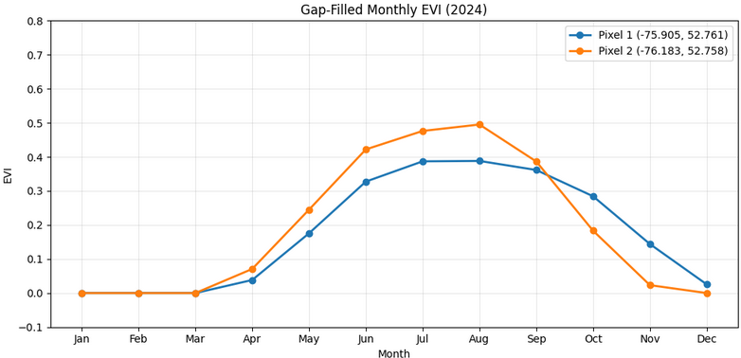
EVI trajectory for 2024 (with backup from 2023-25) for two pixels of Polygon 0 in Quebec
Loading satellite data: 2017-2019
Loading HLS Sentinel-2...
Loading HLS Landsat...
HLS images: 632
Calculating water frequency across months...
Creating water mask from JRC Global Surface Water...
Calculating monthly composites and derive EVI...
Gap-filling and smoother…
Calculate DHIs…

Example of HLS image availability for target year 2018
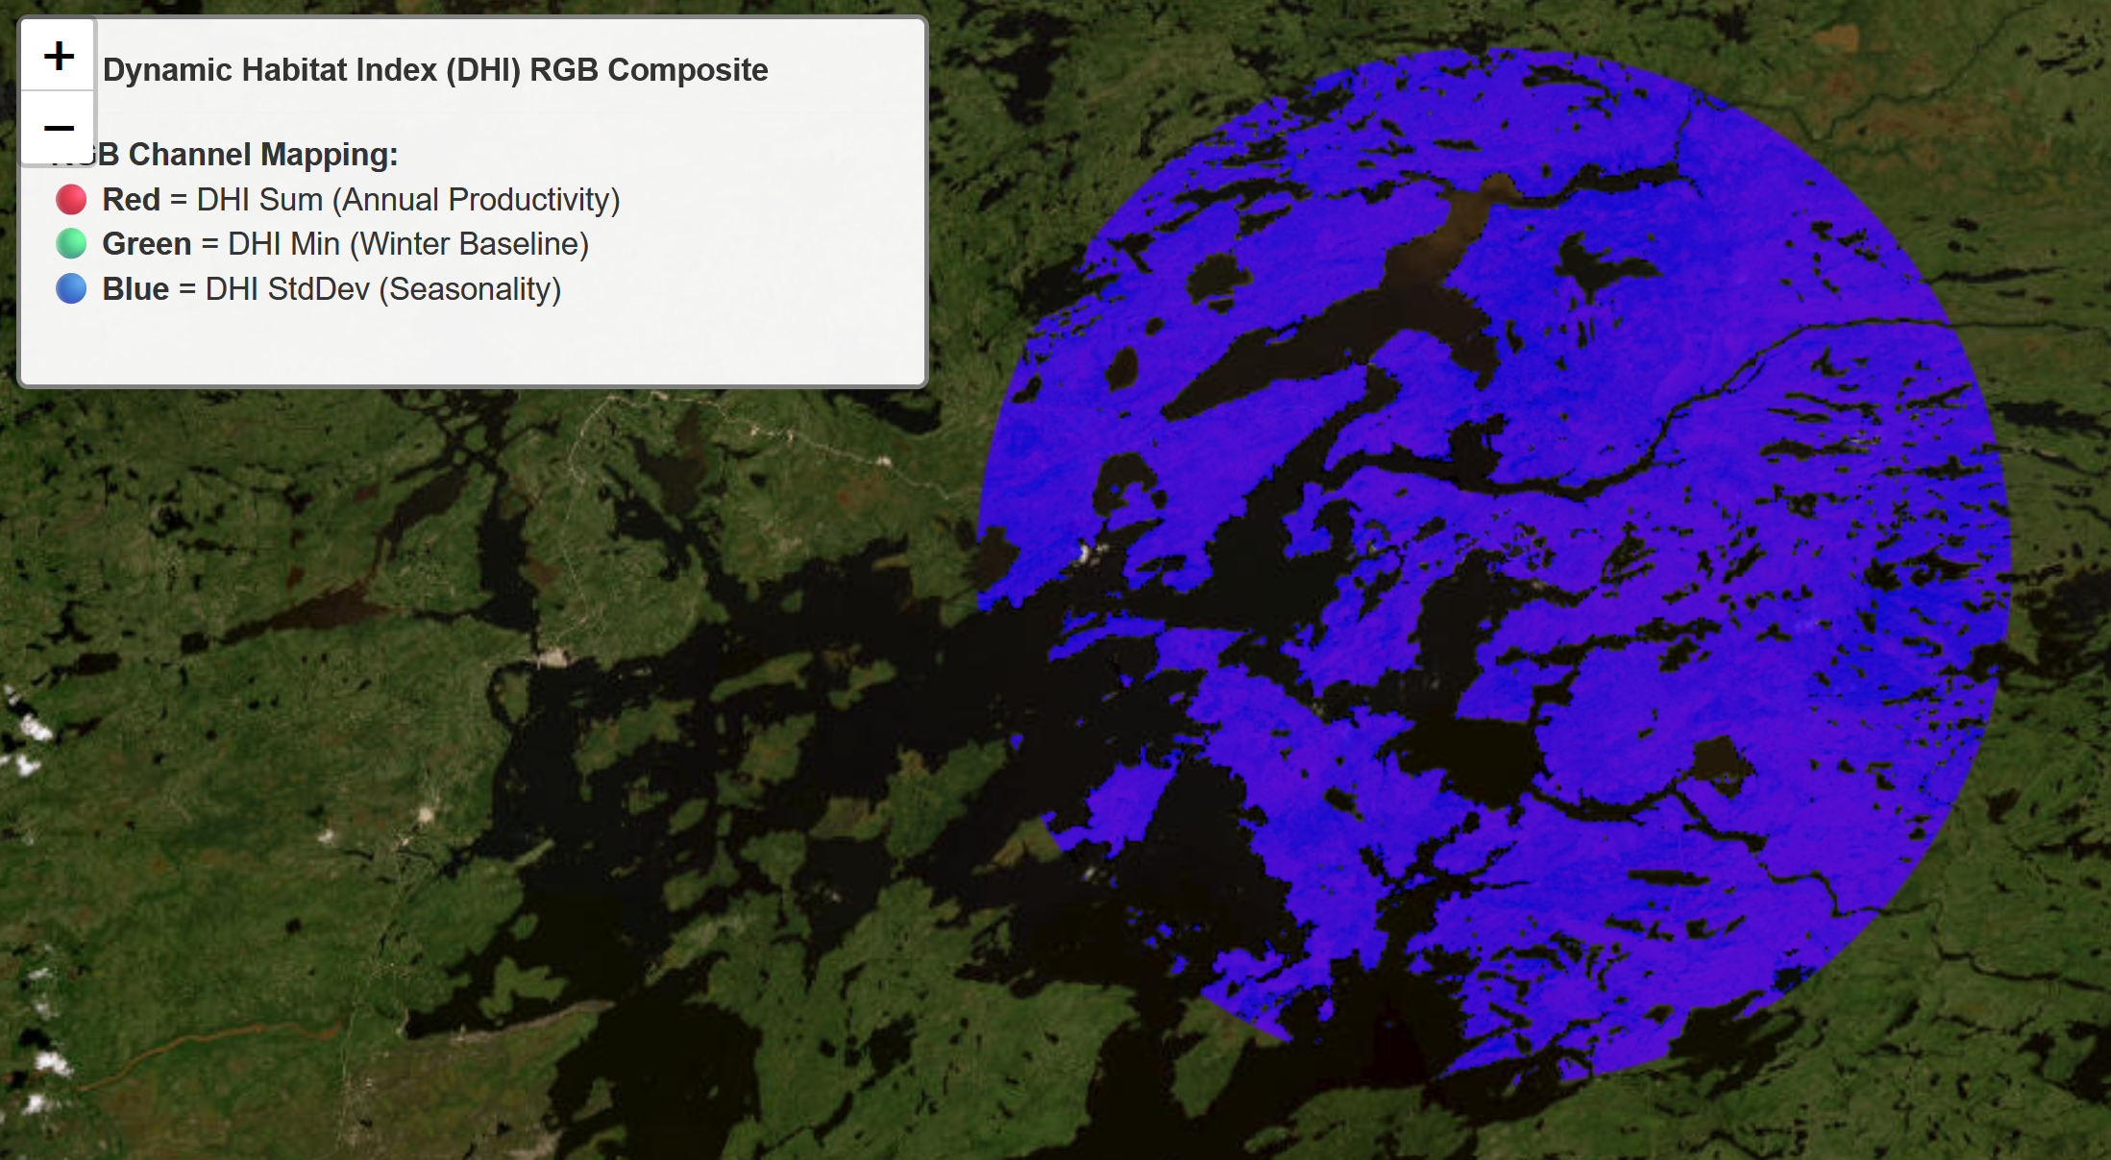
DHI calculation for Polygon 0 in Quebec in a multi-band image, for better presentation DHIs indicators need to be normalized to 0-1
Version control
Single polygon test: HLSEVIma6.ipynb
Multiple polygons: HLSEVIma8cl. ipynb
Possible improvements:
  - DHI min better perhaps done on minima plus surrounding t+1, t-1

